Life cycle analysis.

Definition:

Life cycle assessment (LCA) is an environmental assessment method that examines the potential impacts of a product or service throughout its life cycle, from extraction of raw materials to the end of life.

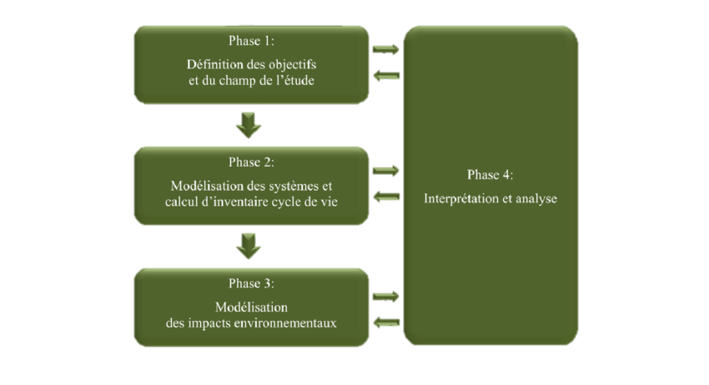

* The Four (04) phases of the LCA:

Phase 1: Definition of the objectives and scope of the study.

**Goal of the study:**

* Study the environmental impacts of our boat over its entire life cycle.
* Find ways to reduce the environmental impact of the boat.
* Compare the environmental impact of several materials applied to the boat.

**Function:** Racing boat.

**The functional unit:** Travel a distance of 0.2m per second with a power provided by the motor which is 80 W.

* The Five (05) stages of the life cycle:

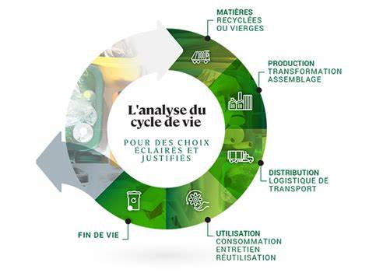

1. Extraction and production of raw materials (iroko):

* Sustainable logging of iroko, a very resistant tropical wood species.
* Transformation of raw wood into planks and other shipbuilding elements.
* Impacts linked to logging (deforestation, biodiversity, CO2 emissions, etc.).

1. Production of the boat:

* Cutting, shaping and assembling the different pieces of iroko wood.
* Addition of equipment, rigging, engine, etc.
* Impacts of construction processes (energy consumption, wood waste, etc.).

1. Distribution and transportation:

* Transport of the boat from the shipyard to the point of sale or delivery.
* Impacts linked to the different modes of transport used (truck, boat, etc.).

1. Use of the boat:

* Fuel and oil consumption during navigation.
* Maintenance and possible repairs of the iroko wood boat.
* Environmental impacts of boat use (emissions, discharges, etc.).

1. End of life of the boat:

* Dismantling and recovery of materials (wood, metal, plastic, etc.).
* Recycling, recovery or elimination of different components.
* Treatment of waste from dismantling.

NB: The Distribution and transportation step will not be ta ken into consideration due to the fact that, the boat is not transported somewhere else.

Phase 2: Systems modeling and life cycle inventory calculation.

Product System.

Entrants

Out going

Natural resources

• Mineral

• Water

• Wood

• Energy

• Transformation and occupation of land.

Emissions in;

• Air

• Co2

• Water

• PO4, SO4

• Soil

• Metals